There are 2 ways to set up a Raspberry Pi NTP Time Server with a GPS Module:

* Raspberry Pi connects to GPS directly via GPIO
* Raspberry PI connects to GPS via a usb-to-serial port adapter (Can't receive PPS signal -> NOT used -> Explain more detail)

In this article, GPS is connected to Raspberry Pi via GPIO.

**HARDWARE:**

Wiring up like following picture:

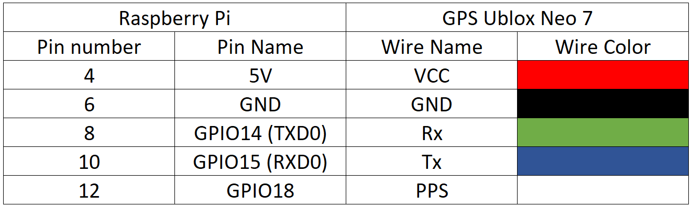

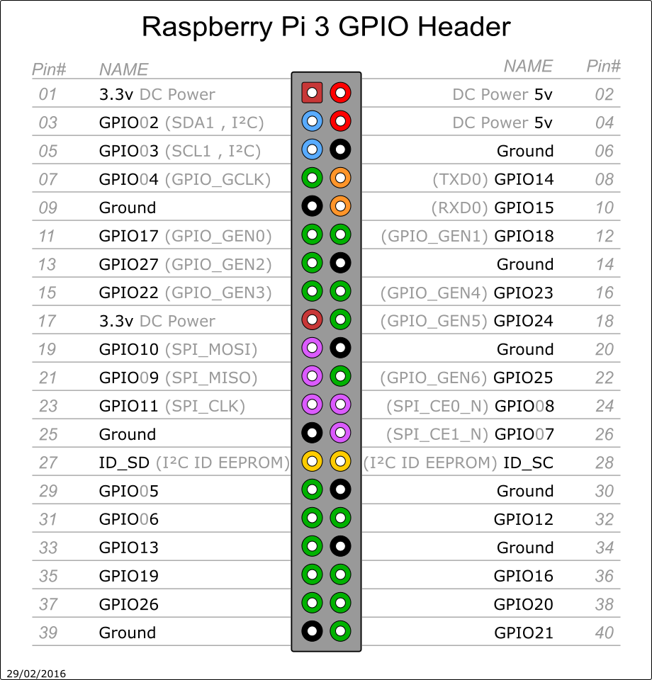

**SOFTWARE SETUP:**

**PPS setup:**

$ sudo raspi-config

1. Expand Filesystem

2. Advanced Options 🡪 Disable Serial Shell (optional)

3. Reboot

$ sudo apt-get update

$ sudo apt-get dist-upgrade

$ sudo rpi-update

$ sudo reboot

$ sudo apt-get install pps-tools

$ sudo apt-get install libcap-dev

$ sudo apt-get install libssl-dev

$ sudo dpkg-reconfigure tzdata (For setting all times in UTC)

$ sudo nano /boot/cmdline.txt (Add bcm2708.pps_gpio_pin=18 at the end of the line.)

$ sudo nano /boot/config.txt (Add dtoverlay=pps-gpio,gpiopin=18 on a new line.) 🡪 Save and close

$ sudo nano /etc/modules (Add pps-gpio on a new line, if it is not existed.) 🡪 Save and close.

Reboot

**PPS verify:**

dmesg | grep pps

Note that with the Raspberry Pi 2, or with more recent versions of Raspbian, you may see:

|  |
| --- |
| [ 10.172015] pps pps0: new PPS source pps-gpio.-1 |

sudo ppstest /dev/pps0

**NTP setup:**

wget http://archive.ntp.org/ntp4/ntp-4.2/ntp-4.2.8p11.tar.gz

tar zxvf ntp-4.2.8p11.tar.gz

cd ntp-4.2.8p11

./configure --enable-linuxcaps (Note that for Raspbian Jessie you should add "--enable-linuxcaps")

make

sudo make install

sudo service ntp stop

sudo cp /usr/local/bin/ntp* /usr/bin/ && sudo cp /usr/local/sbin/ntp* /usr/sbin/

sudo nano /etc/ntp.conf

**Enabling PPS/ATOM support in NTPD:**

In editing */etc/ntp.conf* file, add these lines:

server 127.127.22.0 minpoll 4 maxpoll 4

fudge 127.127.22.0 refid PPS

Amend this line to add a trailing "prefer":

server 0.debian.pool.ntp.org iburst prefer

sudo service ntp restart

After a few minutes run: ntpq –pn

**Solution to Raspberry Pi 3 UART & Bluetooth issue:**

1. Update Raspberry Pi:

$ sudo apt-get update

$ sudo apt-get upgrade

$ sudo apt-get dist-upgrade

$ sudo rpi-update

2. For versions of **Jessie** before 2016-Mar-18, add two lines at the end of */boot/config.txt*

# Allow the normal UART pins to work

dtoverlay=pi3-disable-bt-overlay

3. For versions of Jessie after 2016-Mar-18, add two lines at the end of */boot/config.txt*

# Allow the normal UART pins to work

dtoverlay=pi3-miniuart-bt

4. Stop the Bluetooth modem from trying to use the UART:

$ sudo systemctl disable hciuart

5. If you have smsc95xx.turbo_mode=N in your */boot/cmdline.txt*, remove it.

6. Reboot your Raspberry Pi

$ sudo reboot

Check if Raspberry Pi see gps module:

$ sudo apt-get install minicom

$ minicom -b 9600 -o -D /dev/ttyAMA0

**GPSD setup:**

$ sudo apt-get install gpsd gpsd-clients python-gps

Now try and start the gpsd service temporarily:

$ sudo gpsd /dev/ttyAMA0 -n -F /var/run/gpsd.sock

$ cgps -s

**Configuring gpsd to auto-start:**

Made the following changes to */etc/default/gpsd*:

|  |
| --- |
| # Default settings for the gpsd init script and the hotplug wrapper.  # Start the gpsd daemon automatically at boot time  START_DAEMON="true"  # Use USB hotplugging to add new USB devices automatically to the daemon  USBAUTO="false"  # Devices gpsd should collect to at boot time.  # They need to be read/writeable, either by user gpsd or the group dialout.  DEVICES="/dev/ttyAMA0"  # Other options you want to pass to gpsd  GPSD_OPTIONS="-n"  GPSD_SOCKET="/var/run/gpsd.sock" |

Stop systemd gpsd service:

$ sudo systemctl stop gpsd.socket

$ sudo systemctl disable gpsd.socket

Set gpsd to start automatically:

$ sudo ln -s /lib/systemd/system/gpsd.service /etc/systemd/system/multi-user.target.wants/

Restart GPSD service:

$ sudo service gpsd restart

**Link NTP to GPSD:**

Add following lines to *ntp.conf* file:

# Coarse time reference-clock - nearest second

server 127.127.28.0 minpoll 4 maxpoll 4 iburst prefer

fudge 127.127.28.0 time1 +0.105 flag1 1 refid GPSD stratum 1

**REFERENCE:**

* Quick start NTP on the Raspberry Pi - *http://www.satsignal.eu/ntp/Raspberry-Pi-quickstart.html*
* The Raspberry Pi as a Stratum-1 NTP Server - *http://www.satsignal.eu/ntp/Raspberry-Pi-NTP.html*
* GPSD Time Service HOWTO - *http://www.catb.org/gpsd/gpsd-time-service-howto.html*